Department of Computer Science and Engineering (Data Science)
CSDS-A | Batch A13 (CSE - Data Science, Section A)
AI-Enabled Digital Examination Seating Management System
(SeatWise)
S.No. | Student name | Roll / hall ticket no.
1 | A.SANJAY | 23K91A6702
2 | CH.NAVEEN | 23K91A6743
3 | D.KOTESH | 24K95A6705
4 | A.AKSHITH | [Roll number to be confirmed]
Under the guidance of: [GUIDE NAME], [DESIGNATION]
BLOCK DIAGRAMS
This document collects every design diagram of SeatWise. Each diagram was drawn from the real code and database models and is followed by a paragraph that explains it. The diagrams were generated by scripts/make_diagrams.py with matplotlib.
Table 1: Diagrams in this document
No. | Diagram | Shows
1 | System architecture | Layers: browsers, React front end, FastAPI back end and services, storage
2 | High-level workflow | Ten steps from import to analysis
3 | DFD level 0 | Context: SeatWise and its three external entities
4 | DFD level 1 | Eight processes and five data stores
5 | DFD level 2 | Expansion of the plan-generation process
6 | Use-case diagram | Actors and their use cases
7 | Sequence diagram | Generate, publish and look up
8 | ER diagram | Sixteen database tables
9 | UML class diagram | Domain entities, engine types and services
10 | Algorithm flowchart | Control flow of the seating engine

1 System Architecture
The architecture has four layers. Users work in a browser on a PC, tablet or phone: the examination controller on the administrator console, the invigilator on a tablet, and the public on the home and lookup pages. The React front end (port 5113) provides the pages, the seat map and the charts, and it reaches the back end through a data layer that sends the JWT in the Authorization header. The Vite development server forwards /api to the back end, so tablets and phones only need one address.
The FastAPI back end (port 8113) exposes a REST API with JWT authentication, role checks and a rate limit on public endpoints. Behind it sit eight services: the importer, the seating engine, an independent validator, the swap checker, the exports, the attendance service, analytics and the audit service. The back end owns every rule: the front end never decides whether a seat move is legal; it asks the API, so the seat map, the exports and the benchmark all apply identical checks. SQLite stores 16 tables, and a small profile file records the tuned solver budget and the latest benchmark results.
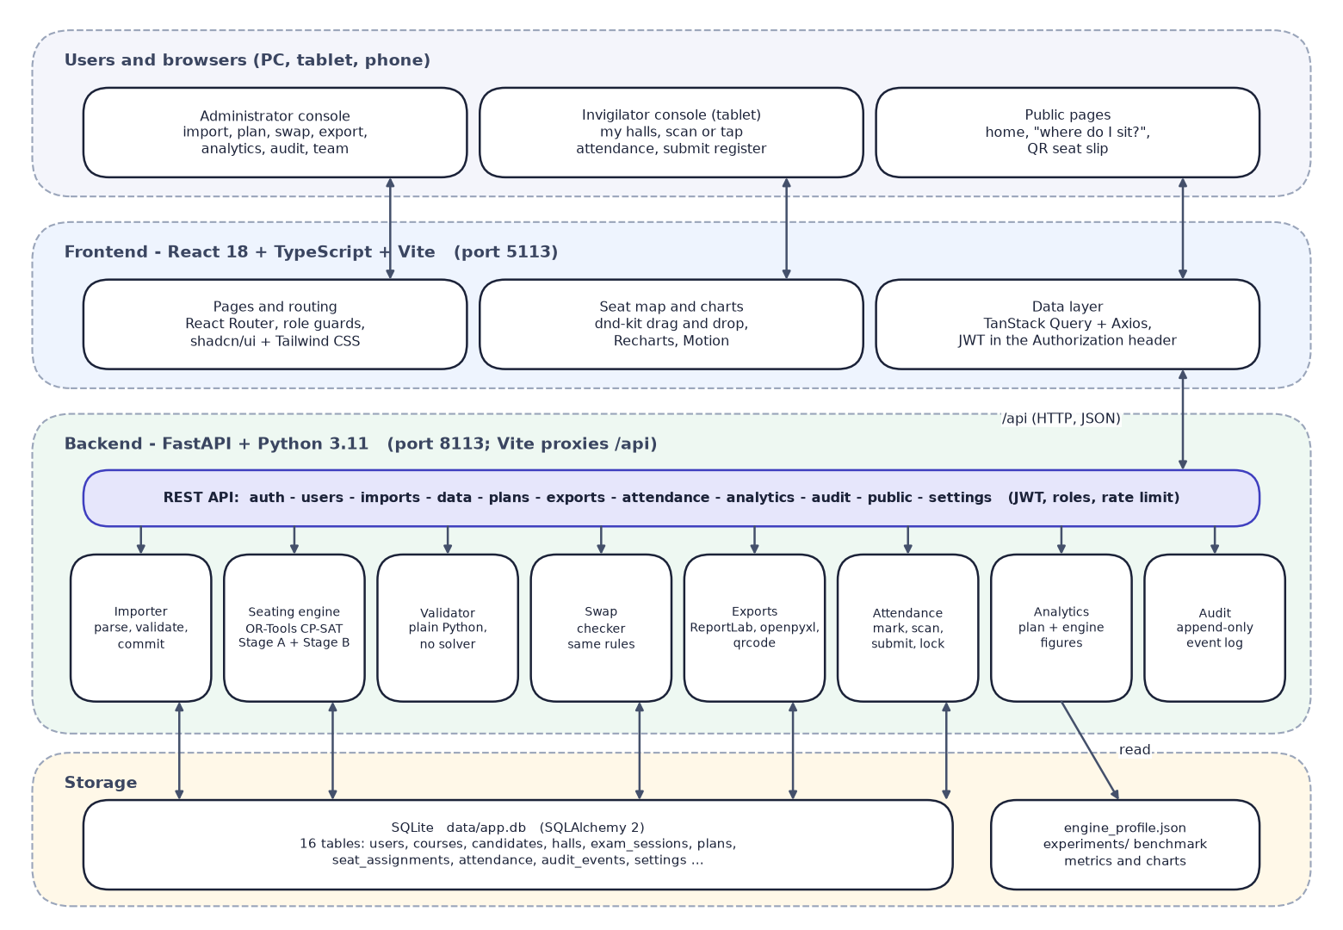
Fig. 1: System architecture of SeatWise

2 High-Level Workflow
The workflow has ten steps. The administrator imports the four data files, which are validated row by row before anything is saved, sets the seating rules, and asks the engine for a plan. An independent validator scores the plan and computes a roll-order baseline for comparison. The administrator reviews the seat map, optionally moves seats with live checks, and publishes the plan, which archives the previous version. Published plans feed the printed outputs, the public lookup and the tablet attendance, and analytics and Verify close the loop.
An impossible request does not fail silently: the pre-check explains the cause (not enough seats, too few accessible seats or one paper larger than the halls can separate) and suggests a fix. Every step writes to the append-only audit trail.
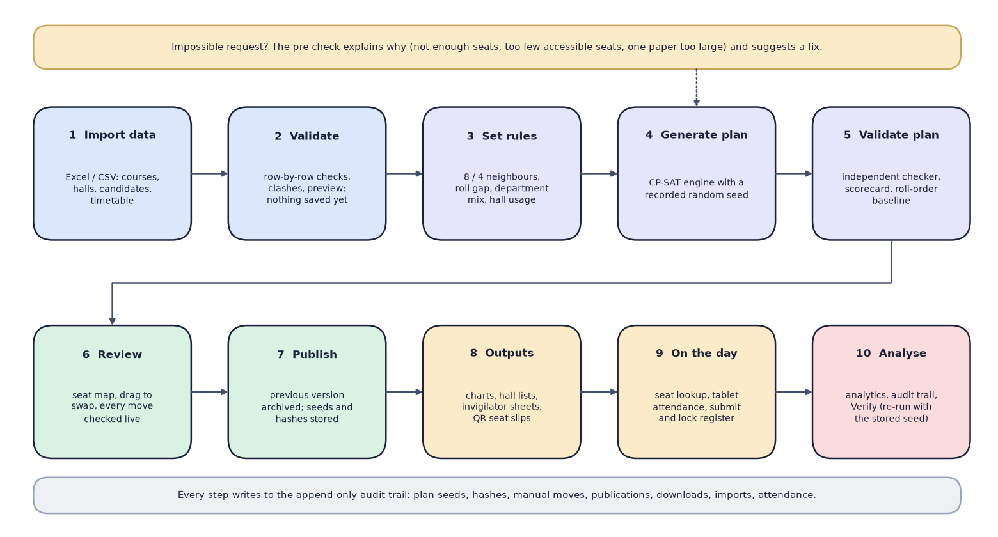
Fig. 2: High-level workflow from data import to analysis

3 Data-Flow Diagram: Level 0
The context diagram shows SeatWise as a single process with three external entities. The exam controller sends data files, rules, a seed and swap or publish commands, and receives validation reports, plans, scorecards, charts, lists, analytics and the audit trail. The invigilator sends attendance marks and scanned slips and receives hall lists, seat maps and register counts. The candidate sends a candidate ID and receives the hall, the seat, a hall map and a QR slip.
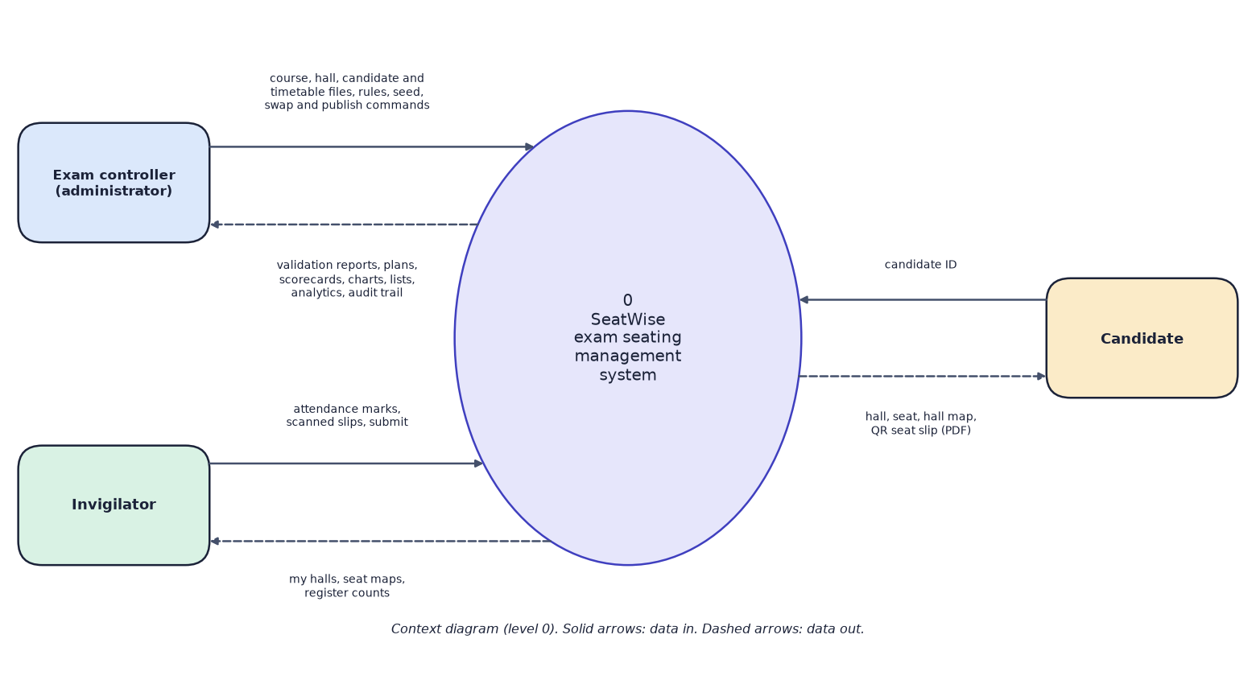
Fig. 3: Data-flow diagram, level 0 (context diagram)

4 Data-Flow Diagram: Level 1
Level 1 opens the system into eight processes and five data stores. Process 1 authenticates users and reads the user and settings store D1. Process 2 imports and validates data and maintains the reference data D2 (courses, candidates, halls, timetable). Process 3 generates a plan from D2 and the rules and writes it to the plans store D3. Process 4 reviews, swaps and publishes plans in D3. Process 5 produces the outputs from published plans. Process 6 answers candidate lookups from published seats. Process 7 records attendance in D4, using the seat lists in D3. Process 8 presents analytics and the audit trail by reading D3, D4 and D5. Processes 2 to 7 append their events to the audit store D5.
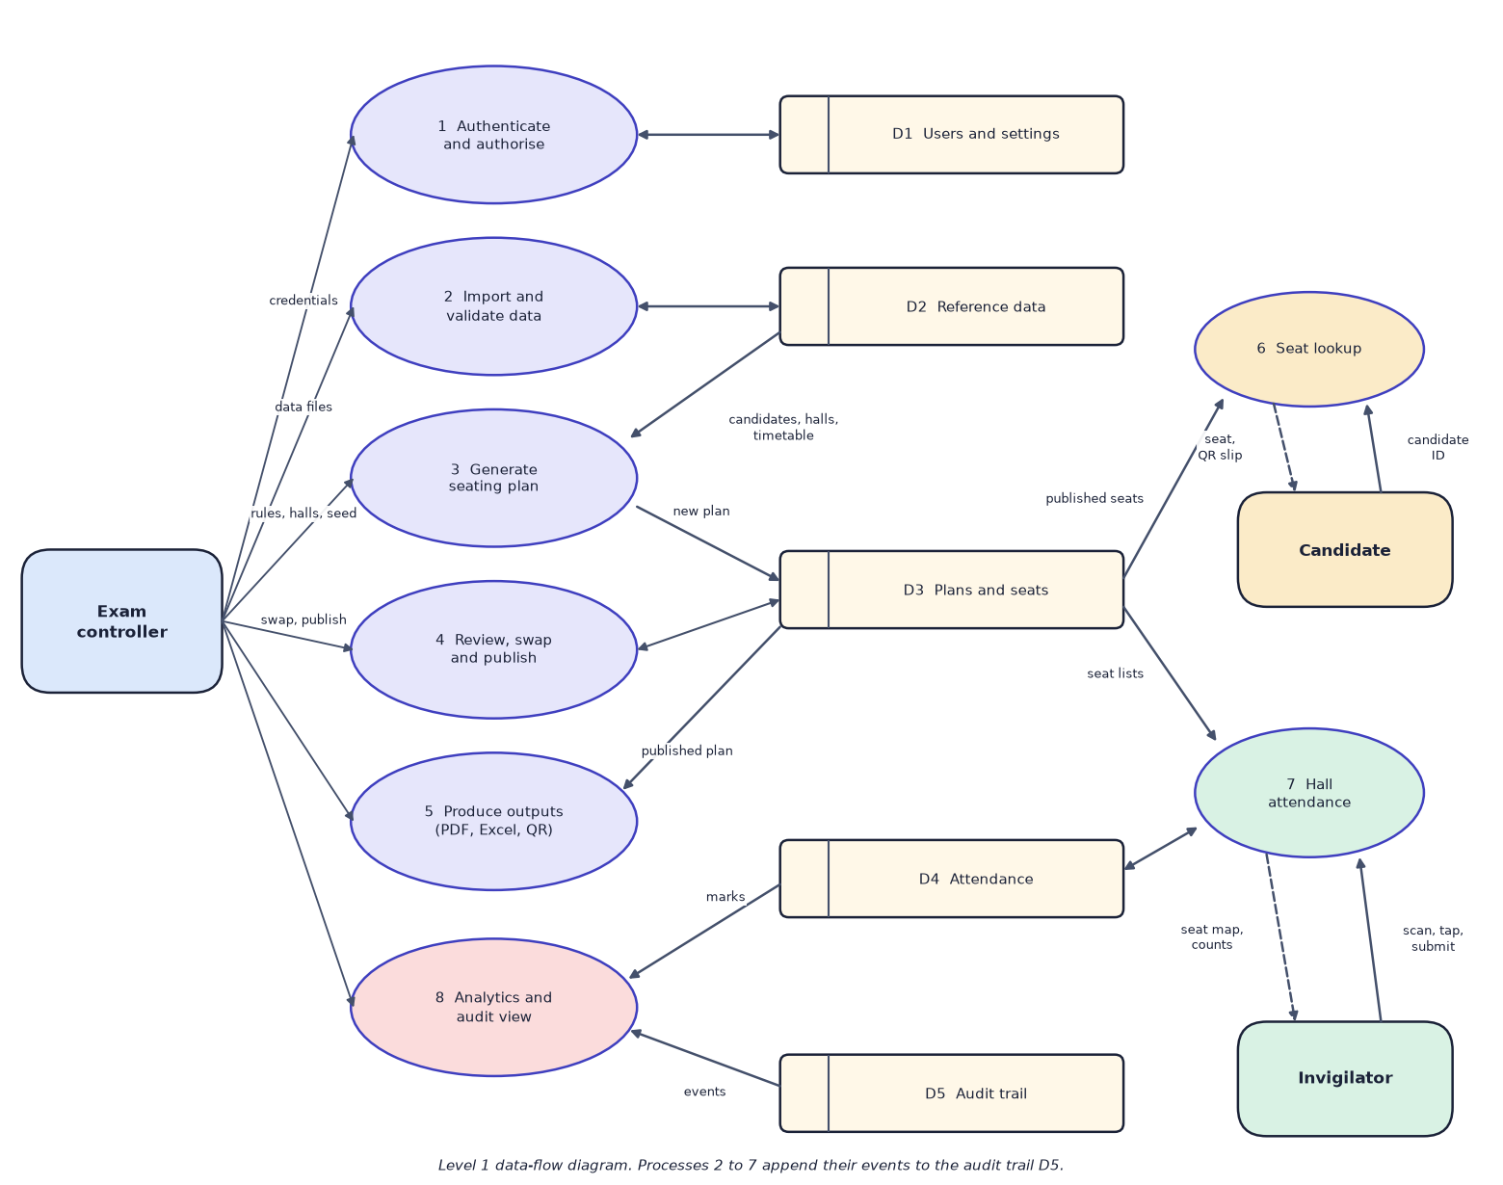
Fig. 4: Data-flow diagram, level 1

5 Data-Flow Diagram: Level 2
Level 2 opens the plan-generation process into seven steps. Sitting data is loaded from the reference data (3.1) and pre-checked (3.2); an impossible request returns plain-language reasons to the controller. Stage A (3.3) allocates groups of candidates to halls and gives each paper a colour class; candidates are then split between halls with a seeded shuffle (3.4), laid out seat by seat in each hall in parallel (3.5), and validated and scored (3.6). The plan, its seats and an audit event are stored with the seed and three fingerprints (3.7). If a hall fails within its budget, the loop returns to Stage A to re-balance.
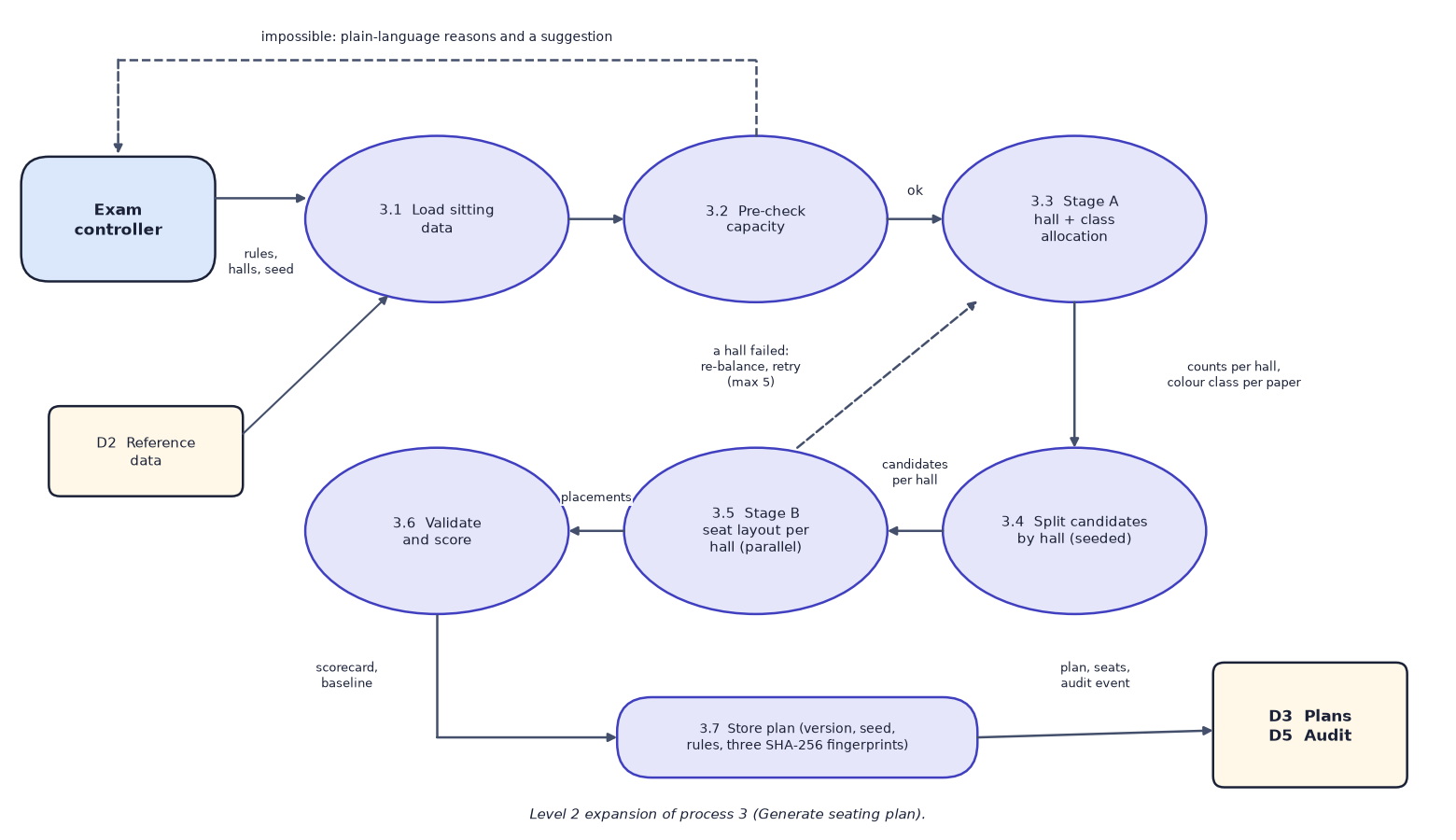
Fig. 5: Data-flow diagram, level 2: expansion of process 3 (generate seating plan)

6 Use-Case Diagram
The administrator can import and validate data, set rules, generate, verify, swap, publish and export plans, view analytics and the audit trail, and manage the team. The invigilator can request an account, view assigned halls, mark attendance, submit and lock the register, and print the chart or sheet of an assigned hall. The candidate needs no account and can look up a seat and download a QR slip. Everyone who is signed in must first sign in.
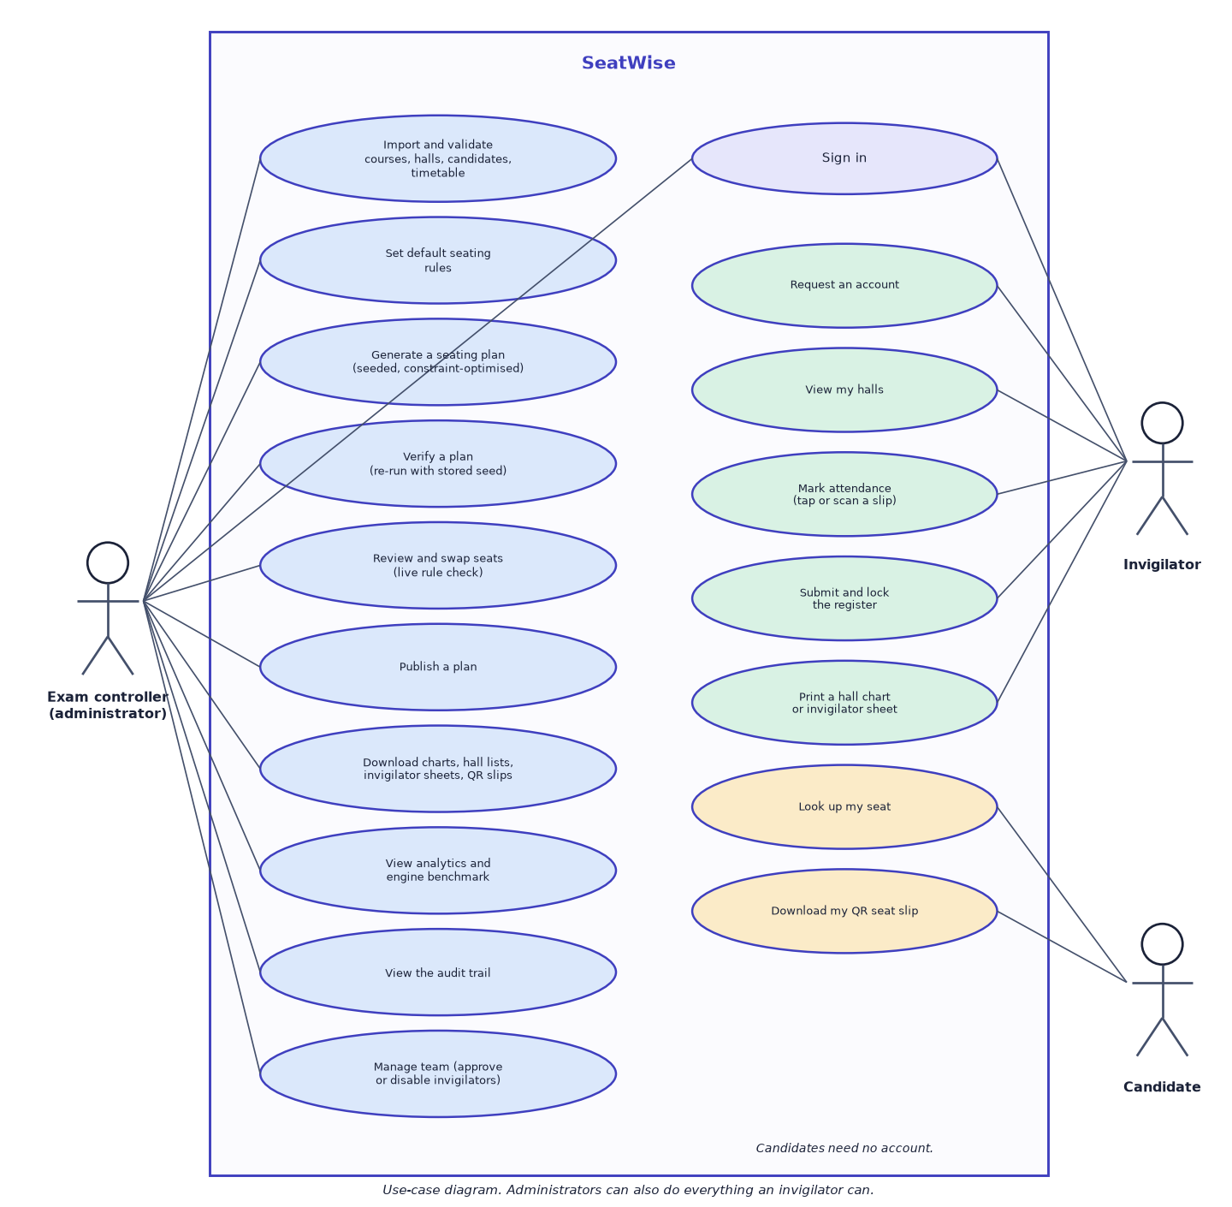
Fig. 6: Use-case diagram

7 Sequence Diagram
The sequence follows the main flow. The administrator chooses a sitting, rules and a seed in the web UI, which sends POST /api/sessions/{id}/plans. The plan service loads candidates, halls and the timetable, calls the engine, validates the result, saves the plan with its seed and fingerprints, and returns the plan and its scorecard. Publishing sets the status, archives the previous version and records an audit event. Later, a candidate enters a candidate ID on the public lookup page, which calls the rate-limited public endpoint and receives the published seat.
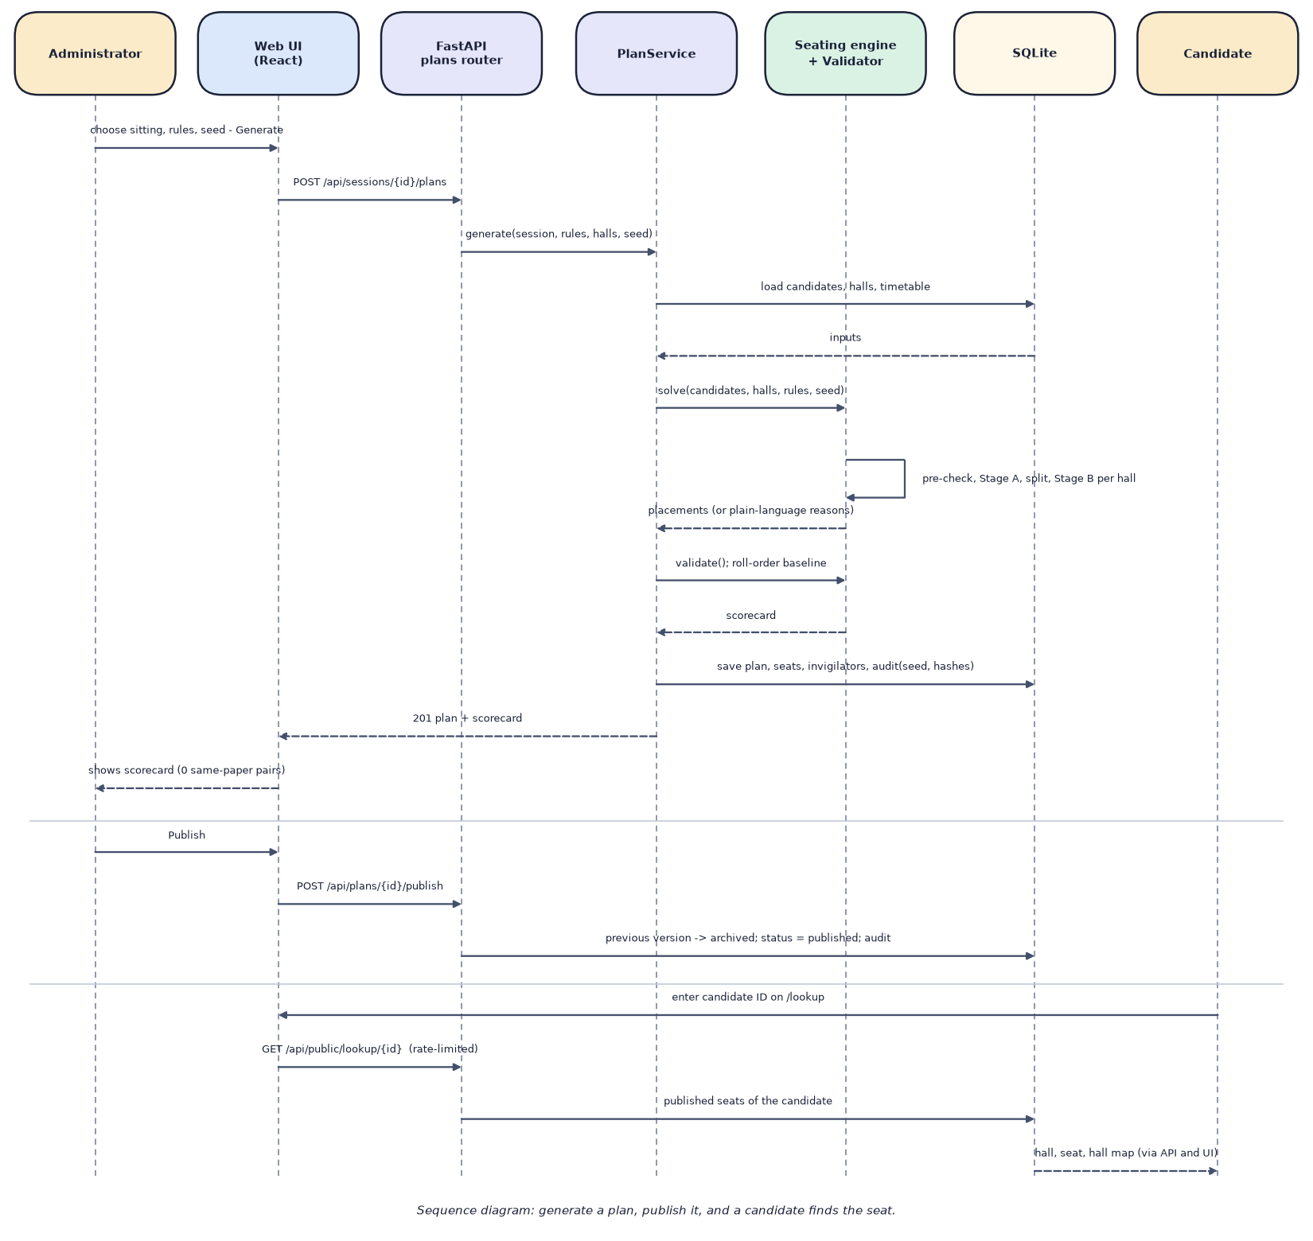
Fig. 7: Sequence diagram: generate a plan, publish it, and a candidate finds the seat

8 Entity-Relationship Diagram
The database has 16 tables. Reference data comprises departments, courses, candidates, registrations (the many-to-many link between candidates and courses), halls and the timetable (exam sessions and session papers). A plan belongs to an exam session and owns its seat assignments, invigilator assignments, attendance marks and hall submissions. Users, audit events, import batches and settings support the application. Every foreign key is marked in its table; only the principal relationships are drawn so that the diagram stays readable.

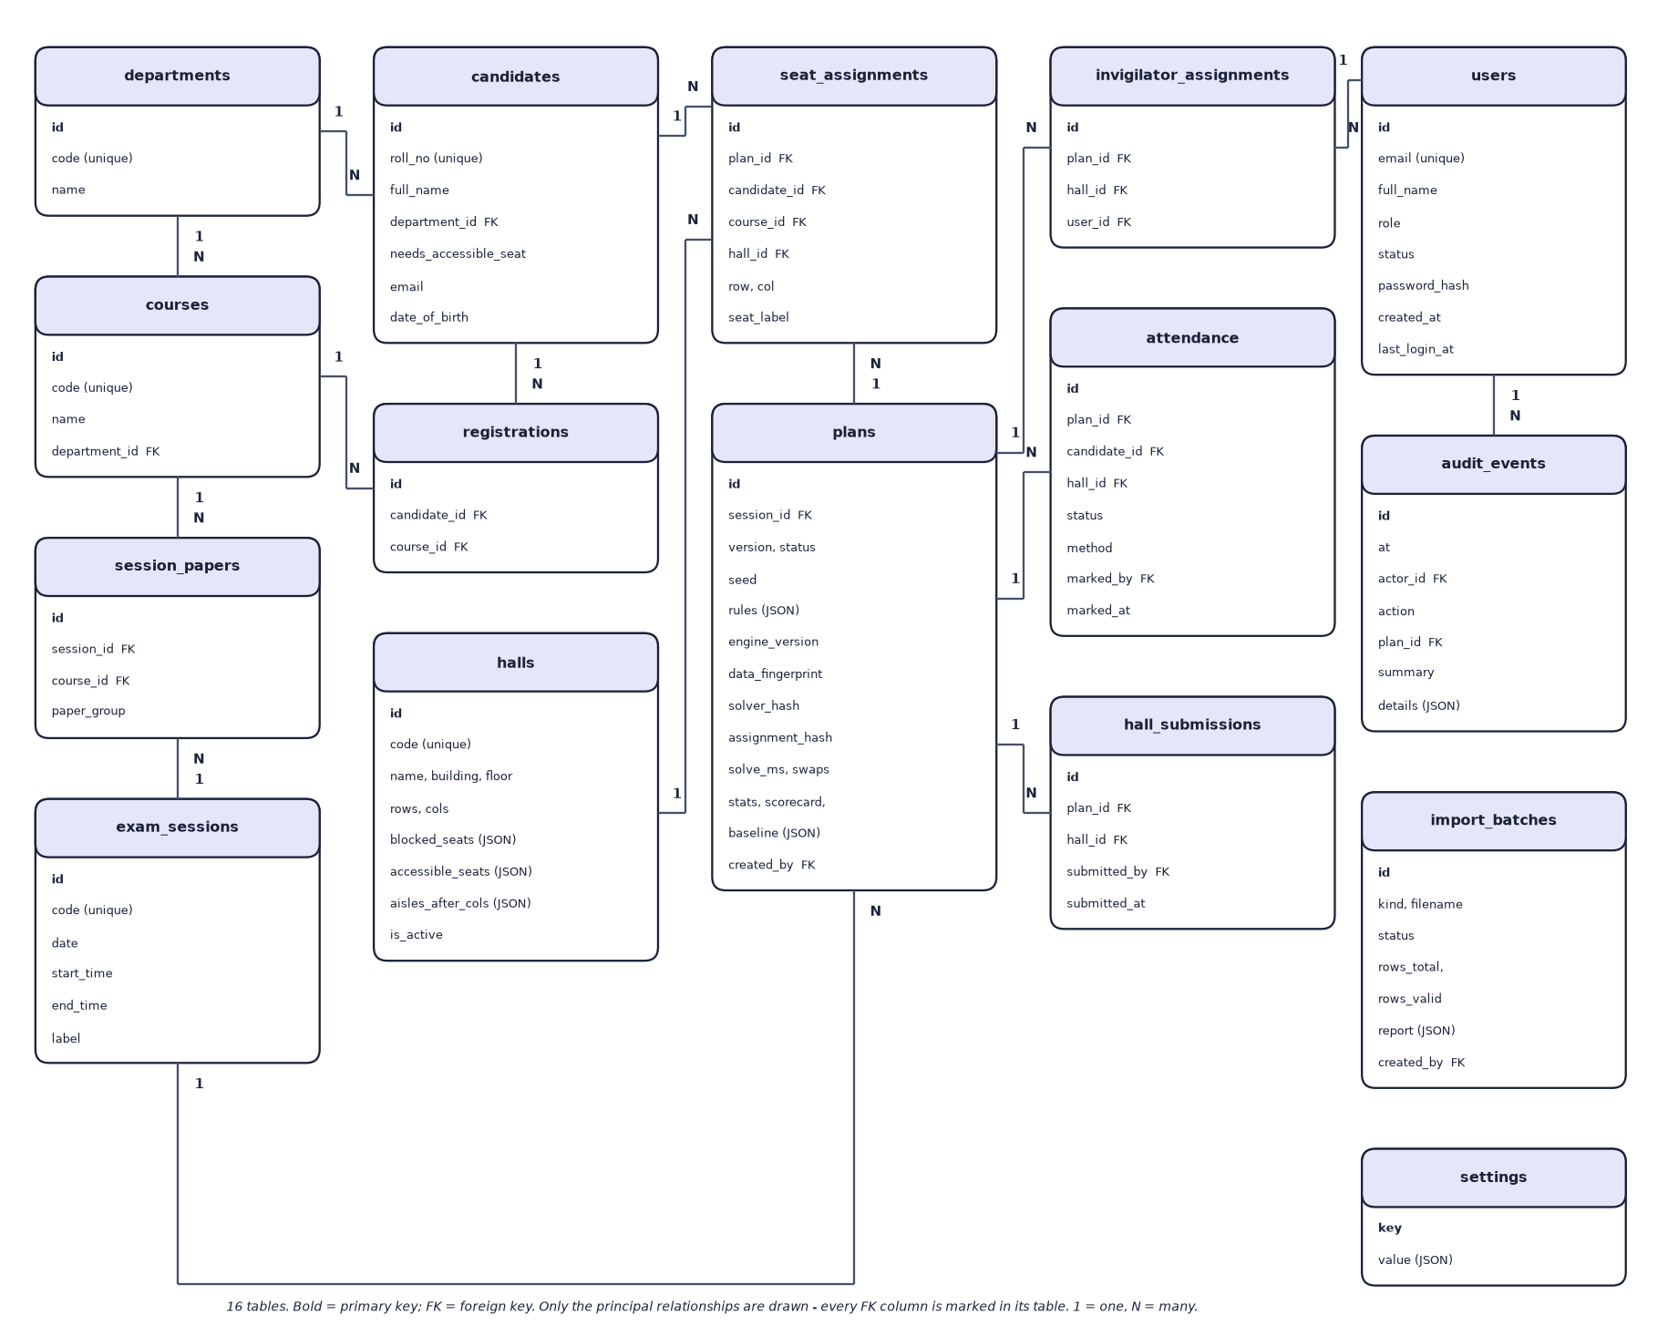
Fig. 8: Entity-relationship diagram of the SeatWise database (16 tables)

9 UML Class Diagram
The class diagram has two groups. The domain model on the left shows the persistent entities and their associations: a department has courses and candidates, candidates register for courses, an exam session schedules papers (courses) and has plans, and a plan owns seat assignments that link a candidate to a hall seat and attendance marks. The group on the right shows the engine's plain data types (rules, candidates, halls, placements and results) and the modules and services that use them: the plan service maps entities to engine types, calls the seating engine, which runs Stage A and Stage B over the seat graph, and checks the result with the validator; the swap checker applies the same rules to manual moves.

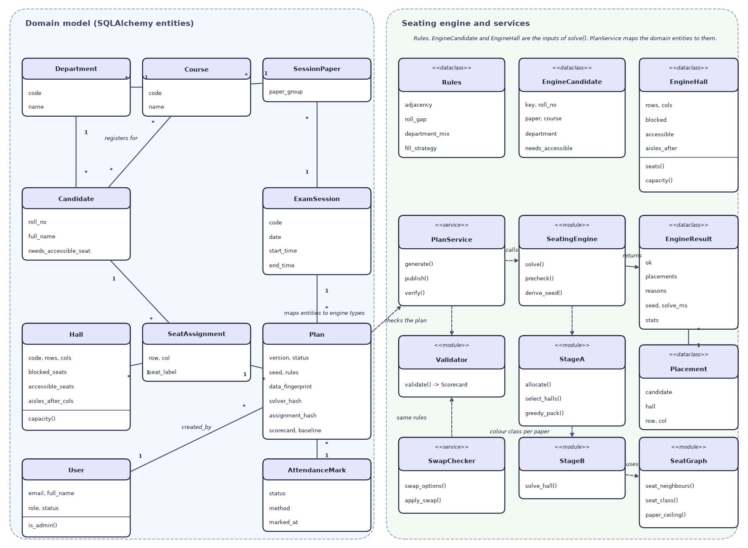
Fig. 9: UML class diagram: domain entities and the seating engine

10 Flowchart of the Core Algorithm
The flowchart is the control flow of the engine's solve function. After loading the sitting, the pre-checks reject impossible requests with reasons. Stage A runs in two passes, the first finding the best allocation and the second choosing among equally good allocations with seeded random weights. Candidates are split between halls with a seeded shuffle, and Stage B lays out every hall in parallel. A hall that finds nothing within its time budget is retried with four times the budget; if it still fails, its capacity is eased and Stage A is re-run, at most five times. A successful result is re-checked by the independent validator and stored with the seed, rules and three SHA-256 hashes.
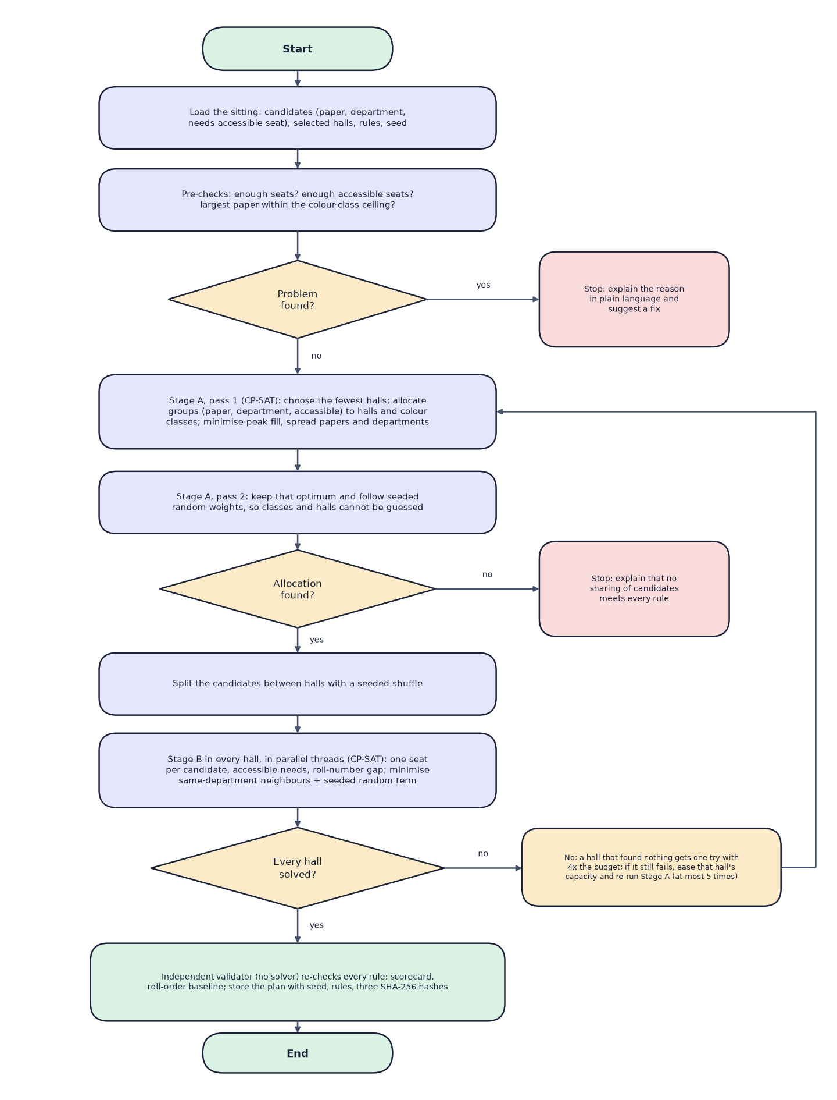
Fig. 10: Flowchart of the core seating algorithm

